

Student Name:………………………………………

SPECIALIST MATHEMATICS

TRIAL EXAMINATION 2

2012

Reading Time: 15 minutes
Writing time: 2 hours

Instructions to students
This exam consists of Section 1 and Section 2.
Section 1 consists of 22 multiple-choice questions and should be answered on the detachable answer sheet on page 28 of this exam. This section of the paper is worth 22 marks.
Section 2 consists of 5 extended-answer questions, all of which should be answered in the spaces provided. Section 2 begins on page 11 of this exam. This section of the paper is worth 58 marks.
There is a total of 80 marks available.
Where more than one mark is allocated to a question, appropriate working must be shown.
Where an exact value is required to a question a decimal approximation will not be accepted.
Unless otherwise stated, diagrams in this exam are not drawn to scale.
The acceleration due to gravity should be taken to have magnitude 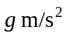where 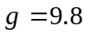
Students may bring one bound reference into the exam.
Students may bring an approved graphics or CAS calculator into the exam.
Formula sheets can be found on pages 25-27 of this exam.

This paper has been prepared independently of the Victorian Curriculum and Assessment Authority to provide additional exam preparation for students. Although references have been reproduced with permission of the Victorian Curriculum and Assessment Authority, the publication is in no way connected with or endorsed by the Victorian Curriculum and Assessment Authority.

© THE HEFFERNAN GROUP 2012
This Trial Exam is licensed on a non transferable basis to the purchasing school. It may be copied by the school which has purchased it. This license does not permit distribution or copying of this Trial Exam by any other party.
SECTION 1

Question 1

An ellipse has its centre at the point 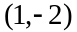. It has a horizontal semi-axis length of 3 and a vertical semi-axis length of 1.
The equation of the ellipse could be

- 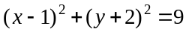
- 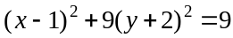
- 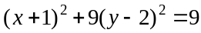
- 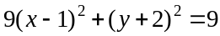
- 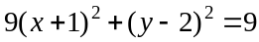

Question 2

The graph of 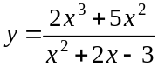 has n straight line asymptotes.
The value of n is

- 0
- 1
- 2
- 3
- 4

Question 3

The function with rule 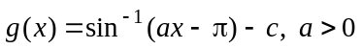 has an implied domain given by

- 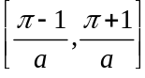
- 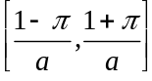
- 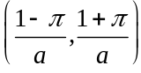
- 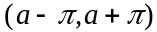
- 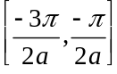

Question 4

The position vector of a particle at time t seconds is given by

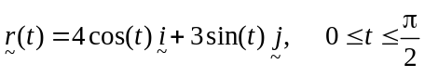.

The Cartesian equation of the path of this particle is

- 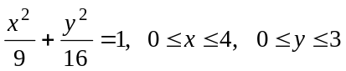
- 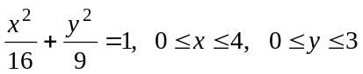
- 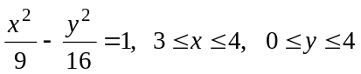
- 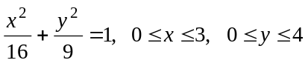
- 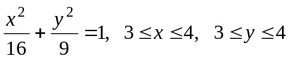

Question 5

Let
Arg 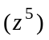 is equal to

- 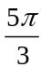
- 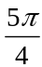
- 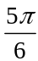
- 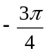
- 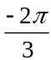

Question 6

Five of the roots of the polynomial equation 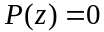 are given by .
Given that 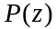 has real coefficients, the minimum number of roots that could have is

- 5
- 6
- 8
- 9
- 10

Question 7

Sixteen points 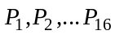 are shown on the Argand diagram below. These points are spaced evenly around a circle of radius two units.
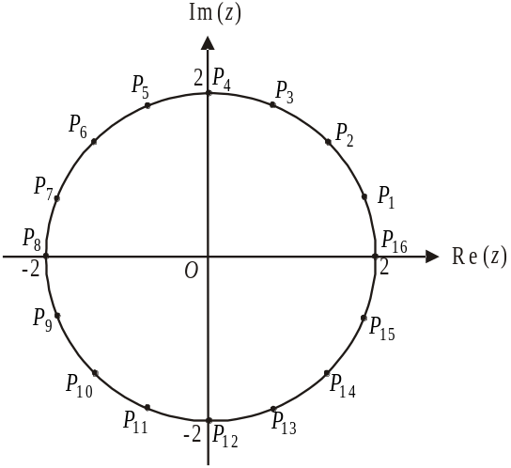

The points that represent all the solutions to the equation 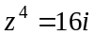 are

- 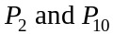
- 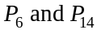
- 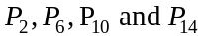
- 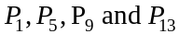
- 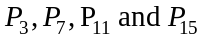

Question 8

Let 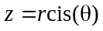. For the complex number , the modulus and argument are respectively given by
- 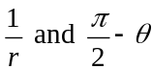
- 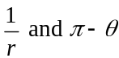
- 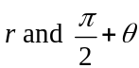
- 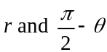

Question 9
The number of times that the graph of 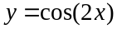 intersects with the graph of 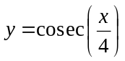 over the domain 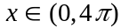 is

- 0
- 1
- 2
- 3
- 4

Question 10

In the diagram shown below is a diameter of the circle.
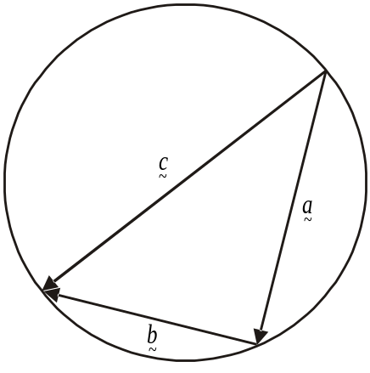

Which one of the following statements is not true?

- 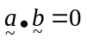
- 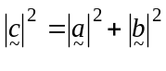
- 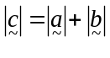
- 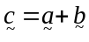
- 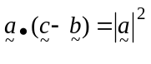

Question 11

Which one of the following is a unit vector perpendicular to 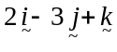

- 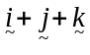
- 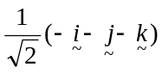
- 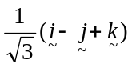
- 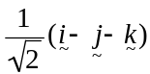
- 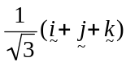

Question 12

The angle between the vectors 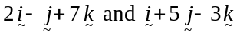 expressed in degrees is closest to

- 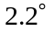
- 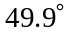
- 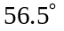
- 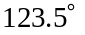
- 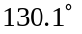

Question 13

The vectors 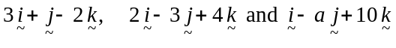, where a is a real constant, are linearly dependent for

Question 14

Using a suitable substitution, 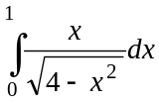 can be expressed as

- 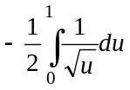
- 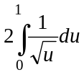
- 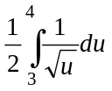
- 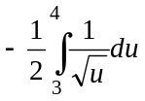
- 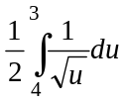

Question 15

Point 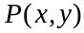 is any point that lies on a particular curve.
The gradient of a line joining point 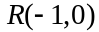 and P is two more than the gradient of the tangent to the particular curve at P.
The coordinates of point P satisfy the differential equation given by

- 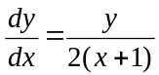
- 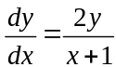
- 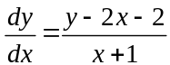
- 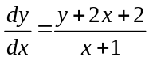
- 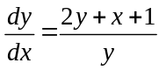

Question 16
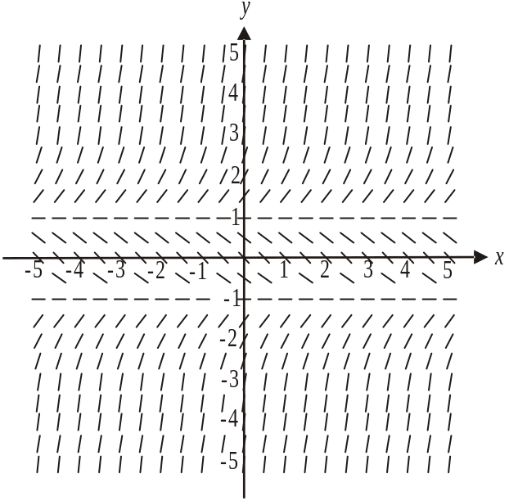

The direction field shown above could be that of the differential equation

- 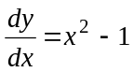
- 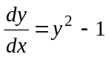
- 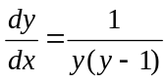
- 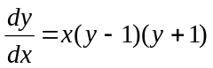
- 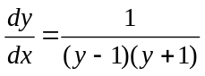

Question 17

A syrup containing 10 g of sugar per litre flows into a vat. The vat initially contains 20 litres of water.
The syrup flows into the vat at the rate of 5 litres per minute and the mixture, which is constantly stirred, leaves the vat at the rate of 3 litres per minute.
A differential equation representing S, the amount of sugar in grams in the vat at time t is

- 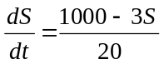
- 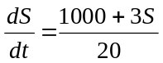
- 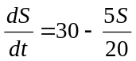
- 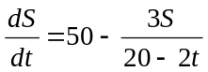
- 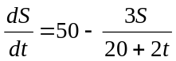

Question 18

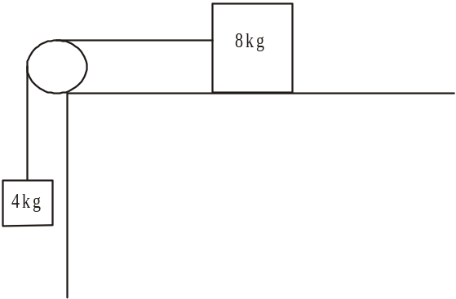

An 8 kg mass on a rough horizontal table is connected to a 4 kg mass by a light inextensible string which passes over a smooth pulley.
The 8 kg mass moves to the left and the 4 kg mass moves towards the ground as the system accelerates at 2 ms⁻². The coefficient of friction between the 8 kg mass and the horizontal table is closest to

- 0.19
- 0.26
- 0.29
- 0.5
- 0.75

Question 19

A particle moves in a straight line with velocity v ms⁻¹ 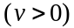 and displacement x, in metres from the origin such that 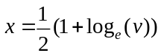.
The acceleration a ms⁻² , of the particle is given by

- 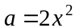
- 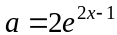
- 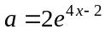
- 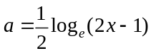
- 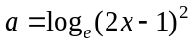

Question 20

The velocity-time graph of a particle moving in a straight line is shown below.

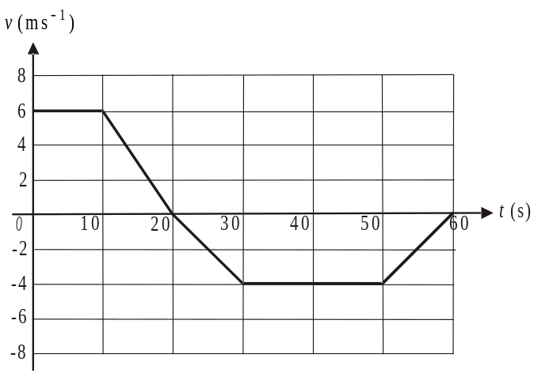

Initially the particle is at a fixed point O. The displacement in metres of the particle from O at time seconds is

- – 120
- – 30
- 0
- 30
- 210

Question 21

A mass of 3 kg has an initial velocity of 10 ms⁻¹. The mass accelerates at a constant rate of 4 ms⁻² in a straight line.
The magnitude of the momentum of the mass in kg ms⁻¹ after it has travelled 5.5 metres is

- 30
- 36
- 55
- 66
- 120

Question 22

A body moves in a straight line such that its acceleration in ms⁻² is given by 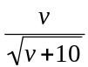 where v is its velocity in ms⁻¹. If its displacement from the origin x, in metres is equal to 6 when 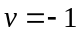 then

- 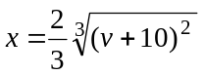
- 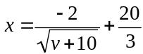
- 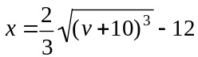
- 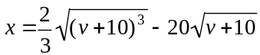
- 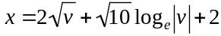
SECTION 2

Question 1

Let 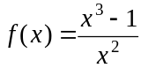 where f has a maximal domain.
- Sketch the graph of 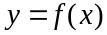 on the set of axes below. Indicate clearly on your graph

- the location of any x-intercepts
- the coordinates of any stationary points expressed as an exact value
- the equation of any asymptotes

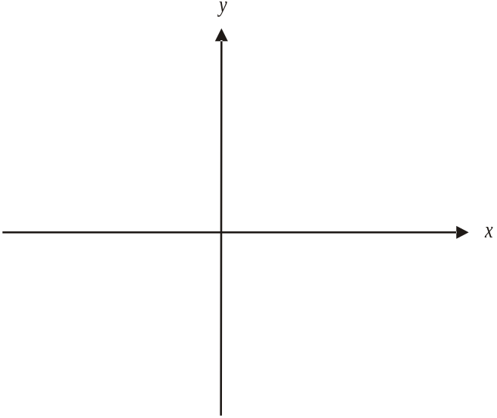

4 marks

- If there are two solutions to the equation 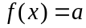 where , find a. Express your answer as an exact value.

1 mark

That part of the graph of f for which 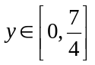, is rotated around the x-axis to form a volume of revolution.

- i. Write down a definite integral that could be evaluated to find this volume of revolution.

- Find the exact value of the definite integral in part i.

- Find the rule and the domain of the function 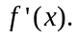

2 marks

- On the set of axes below, sketch the graph of 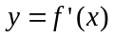.

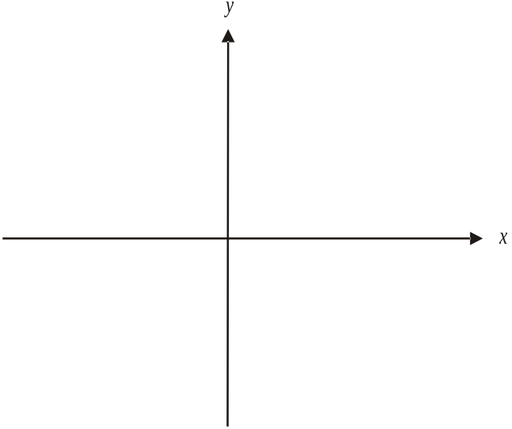

Indicate clearly on your graph the

- coordinates of any axes intercepts
- equation of any asymptotes

2 marks

- Find 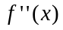 and hence explain why the graph of does not have a point of inflection.

1 mark
Total 13 marks

Question 2

In the complex plane a curve has the equation 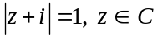.

- Verify that the point 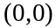 lies on this curve.

1 mark

- Show that the curve has the Cartesian equation given by 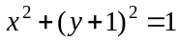.

2 marks

Let L be the line with equation 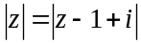. The part of L that appears in the first and fourth quadrants of the complex plane can be given by the equation 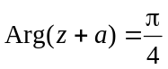.

- Find the value of a.

2 marks

- For the curve with equation 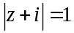 and the line L,

i. find the coordinates of the points of intersection.

______________________________________________________________

  - Sketch the graphs on the Argand diagram below.
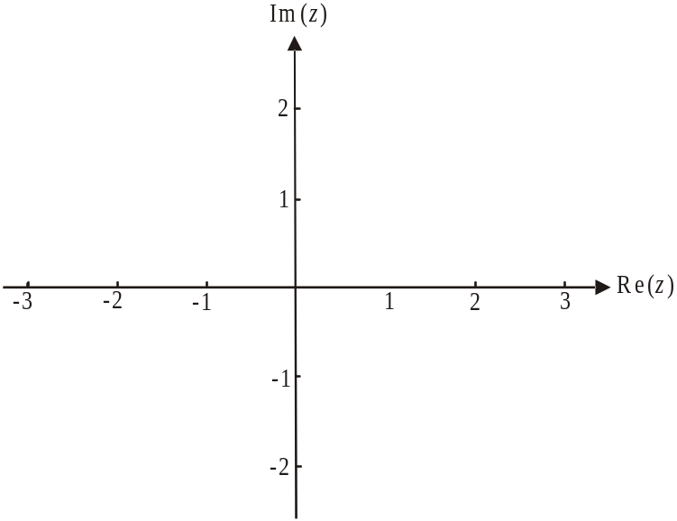

- i. On the Argand diagram below, shade the region given by

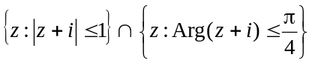.
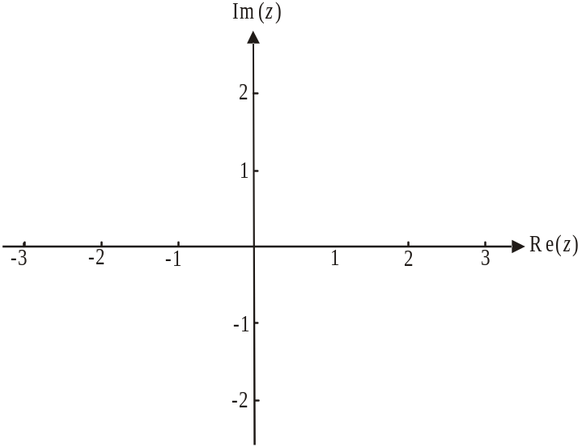

  - Find the area of the shaded region described in part i.

Total 13 marks
Question 3

A model plane is being flown over flat ground at constant velocity when its operator decides to bring it in to land. At this time, seconds. The velocity of the model plane is given by 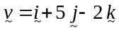. The velocity components are in metres per second.

Five seconds later the model plane passes, at an altitude of 10 metres, directly over a picnic bench which has a position vector 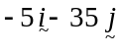 relative to where the plane’s operator is standing.
Let be the unit vector in the east direction, let be the unit vector in the north direction and is a unit vector vertically upwards.

- Show that the position vector of the model plane at time t seconds is given by

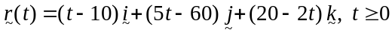.

2 marks

- How long does it take the operator to land the plane?

1 mark

- How far from the feet of the operator does the model plane land?

1 mark

- How far does the plane travel from the time the operator decides to bring it in to land until it lands?

2 marks

- How far from the picnic bench does the plane land? Express your answer in metres correct to 1 decimal place.

2 marks

- At the point where the plane lands, find the angle that it makes with the ground. Express your answer in decimal degrees correct to 1 decimal place.

2 marks
Total 10 marks

Question 4

A mass of 2 kg sits on a rough plane inclined at an angle of 30° to the horizontal. The mass is connected by a light inextensible string which passes over a smooth pulley to a second mass of 5 kg which sits on a rough horizontal plane. The coefficient of friction of both planes is and the acceleration down the plane of the 2 kg mass is a m/sec².

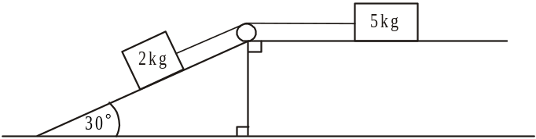

- Write an equation of motion for

  - the 2 kg mass down the plane.

  - the 5 kg mass towards the left along the plane.

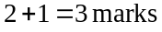

- Show that 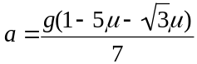.

1 mark

- Find the value of for which the system is in equilibrium. Express your answer correct to 4 decimal places.

1 mark

A pulling force of P newtons, now acts on the 5 kg mass parallel to the horizontal as shown below. Also, the coefficient of friction for both planes is now fixed so that 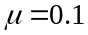.

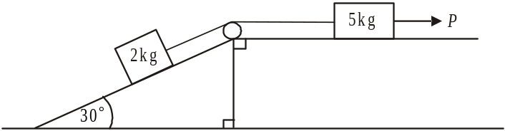

- Find the pulling force of P, in newtons, required so that the 2 kg mass accelerates up the slope at 2m/s². Express your answer correct to 2 decimal places.

3 marks

- The system is in equilibrium for 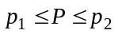 where P is in newtons.
Find the values of 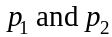 correct to 2 decimal places.

3 marks
Total 11 marks

Question 5

A tank in the shape of an inverted cone is used to store a liquid. The tank is initially full but it develops a small hole at its vertex and the liquid begins to leak out.

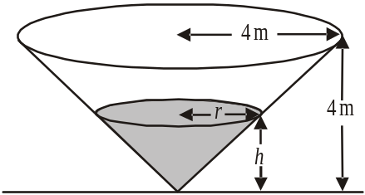

The tank is 4m high and has a radius of 4m. The height of the liquid in the tank at time t hours after it begins to leak is h metres, its radius is r metres and its volume is V cubic metres.
Two hours after the leak begins the height of the liquid is 1m.
The rate at which the liquid leaks from the tank is given by 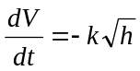 where k is a constant and .

- Show that 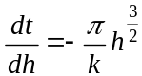.

2 marks

- i. Using substitution, verify that 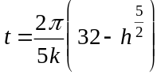 satisfies the differential equation and the initial condition.

- Show that 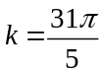

- How long does it take for the tank to empty?

1 mark

- i. Show that 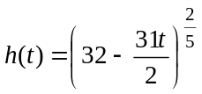.

- On the set of axes below, sketch the graph of the function 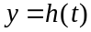 from part i. Clearly mark the coordinates of the endpoints of the graph. Express coordinates as exact values.

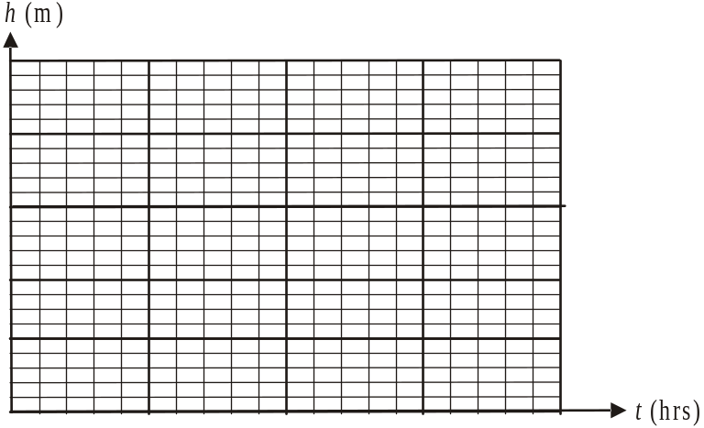

- If the tank contained a different type of liquid, it would have emptied more slowly.
Find the values of k for which this would be the case.

2 marks
Total 11 marks

Specialist Mathematics Formulas

Mensuration
area of a trapezium: 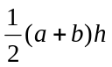
curved surface area of a cylinder: 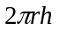
volume of a cylinder: 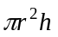
volume of a cone: 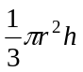
volume of a pyramid: 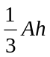
volume of a sphere: 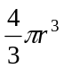
area of a triangle: 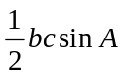
sine rule: 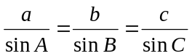
cosine rule: 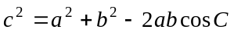

Coordinate geometry
ellipse: 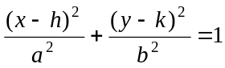 hyperbola: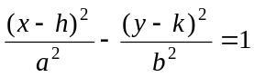

Circular (trigonometric) functions
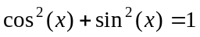
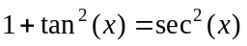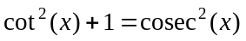
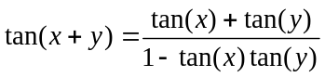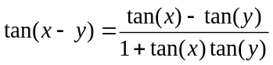
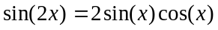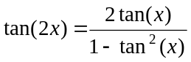
function | 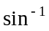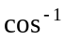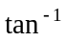
domain  range | 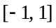  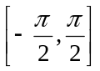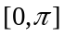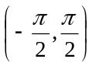

Algebra (Complex numbers)
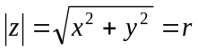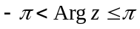
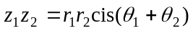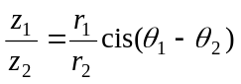
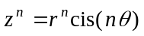 (de Moivre’s theorem)
Reproduced with permission of the Victorian Curriculum and Assessment Authority, Victoria, Australia.
This formula sheet has been copied in 2012 from the VCAA website www.vcaa.vic.edu.au
The VCAA publish an exam issue supplement to the VCAA bulletin.
Calculus

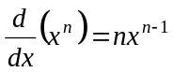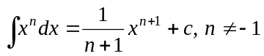
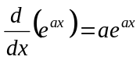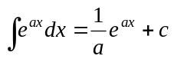
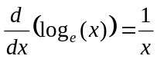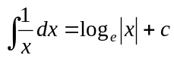
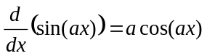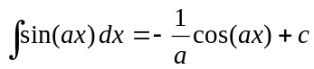
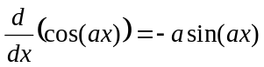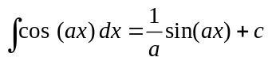
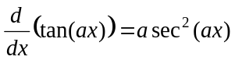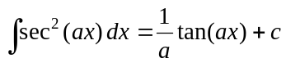
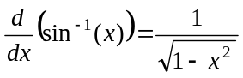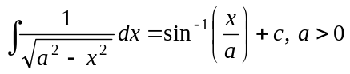
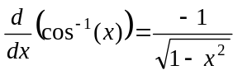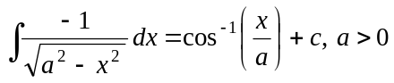
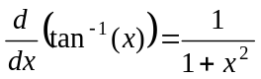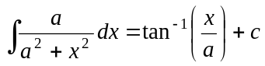

product rule: 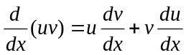
quotient rule: 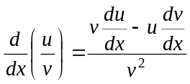
chain rule: 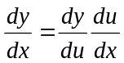
Euler’s method: 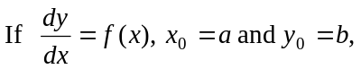
acceleration: 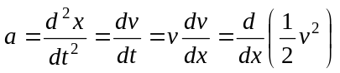
constant (uniform) acceleration: 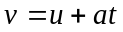 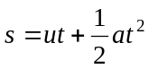 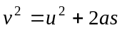 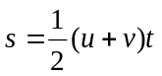

Reproduced with permission of the Victorian Curriculum and Assessment Authority, Victoria, Australia.
This formula sheet has been copied in 2012 from the VCAA website www.vcaa.vic.edu.au
The VCAA publish an exam issue supplement to the VCAA bulletin.

Vectors in two and three dimensions

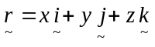
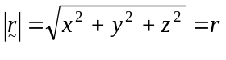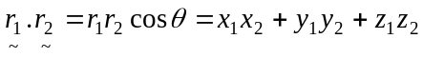
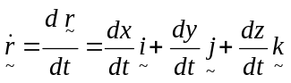

Mechanics

momentum: 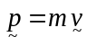
equation of motion: 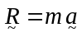
friction: 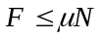

Reproduced with permission of the Victorian Curriculum and Assessment Authority, Victoria, Australia.
This formula sheet has been copied in 2012 from the VCAA website www.vcaa.vic.edu.au
The VCAA publish an exam issue supplement to the VCAA bulletin.

